Assignment 1

🔹 Task 1: Data Entry & Variable Setup
Create a dataset with at least 10–15 observations using the following variables:
- Name (String)
- Age (Numeric)
- Gender (Nominal)
- Department (Nominal)
- CGPA (Scale)
📌 Requirements:
- Define variables in Variable View
- Set correct variable types
- Add labels & value labels
- Define missing values (if applicable)
- Enter all data in Data View
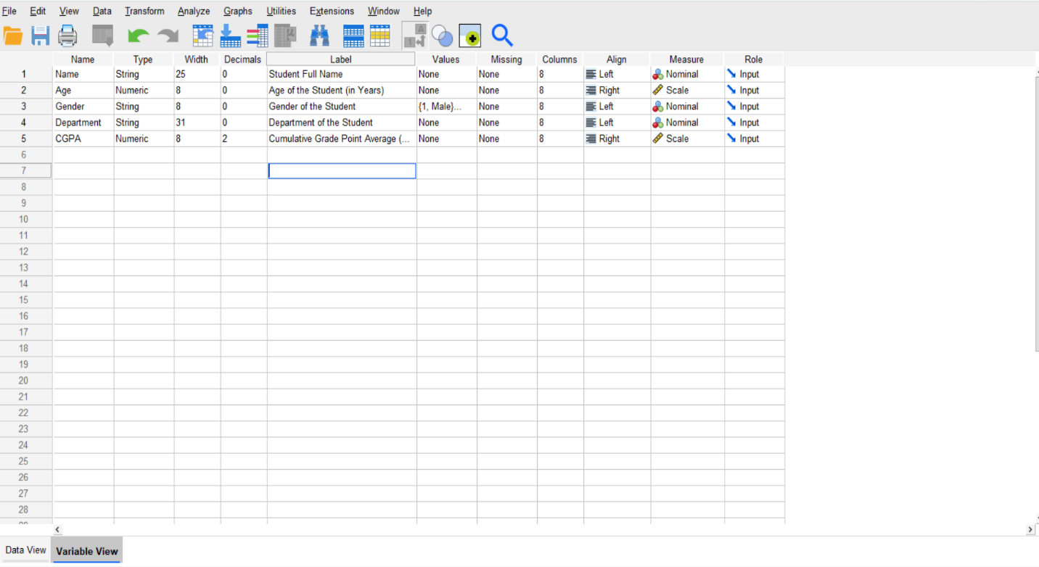
Variable View:

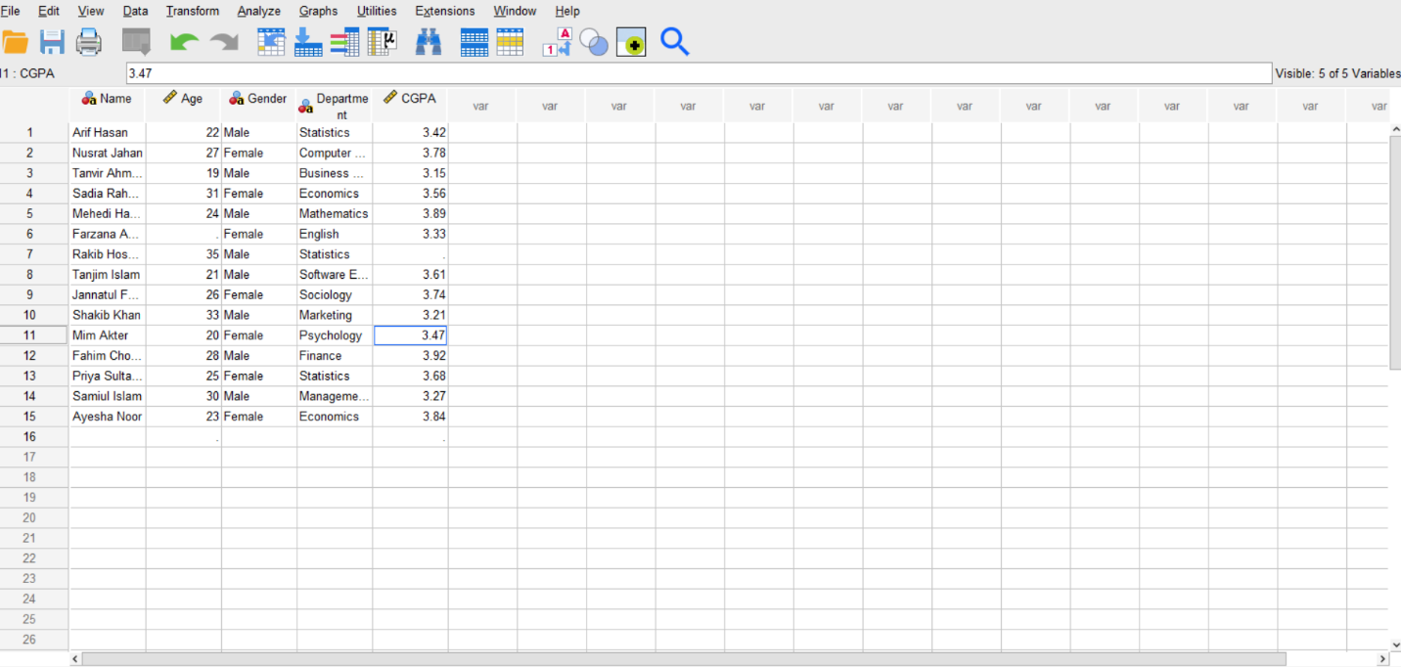
Data View:
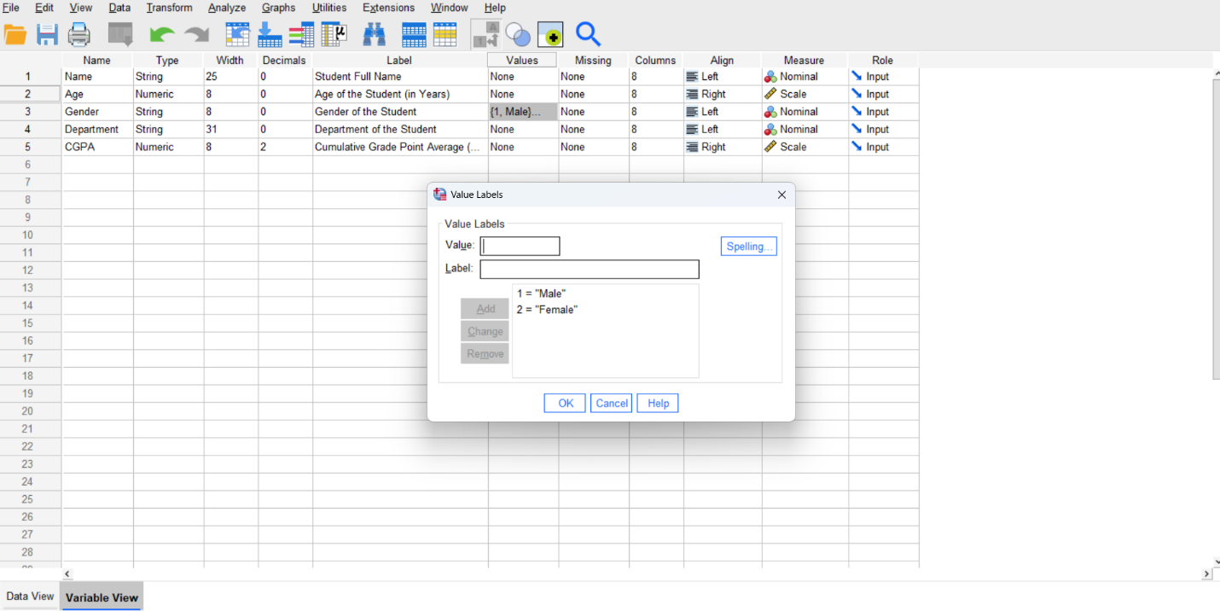
🔹 Task 2: Data Cleaning
Perform the following:
- Identify at least one missing value
- Handle the missing value properly
- Use Recode (same or different variable)
  - Example: Gender → Male = 1, Female = 2
- Create at least one new variable (using Recode/Compute)
Statistics
 |  | Student Full Name | Age of the Student (in Years) | Gender of the Student | Department of the Student | Cumulative Grade Point Average (CGPA)
N | Valid | 15 | 14 | 15 | 15 | 14
 | Missing | 0 | 1 | 0 | 0 | 1

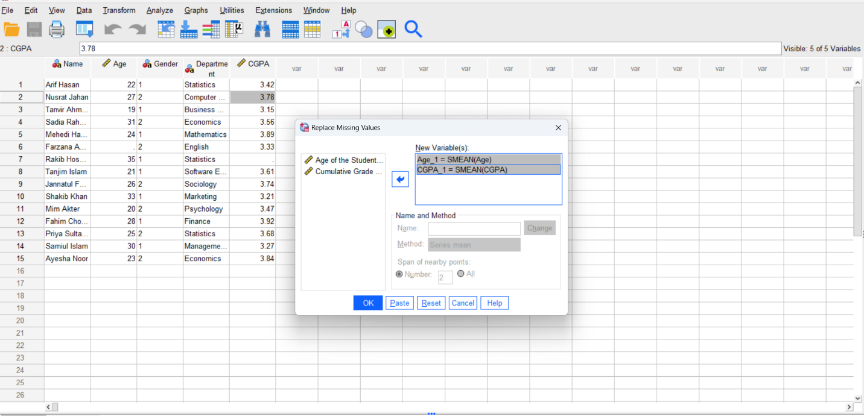
Interpretation: We can see from the frequency table that there is one missing value in both the Age and CGPA variables
Result Variables
 | Result Variable | N of Replaced Missing Values | Case Number of Non-Missing Values |  | N of Valid Cases | Creating Function
 |  |  | First | Last
1 | Age_1 | 1 | 1 | 15 | 15 | SMEAN(Age)
2 | CGPA_1 | 1 | 1 | 15 | 15 | SMEAN(CGPA)
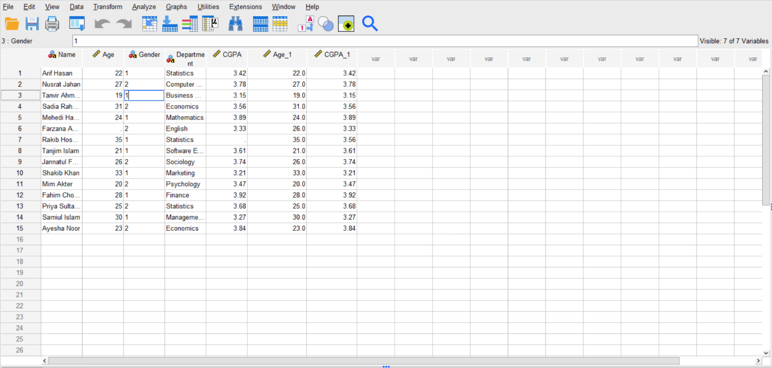
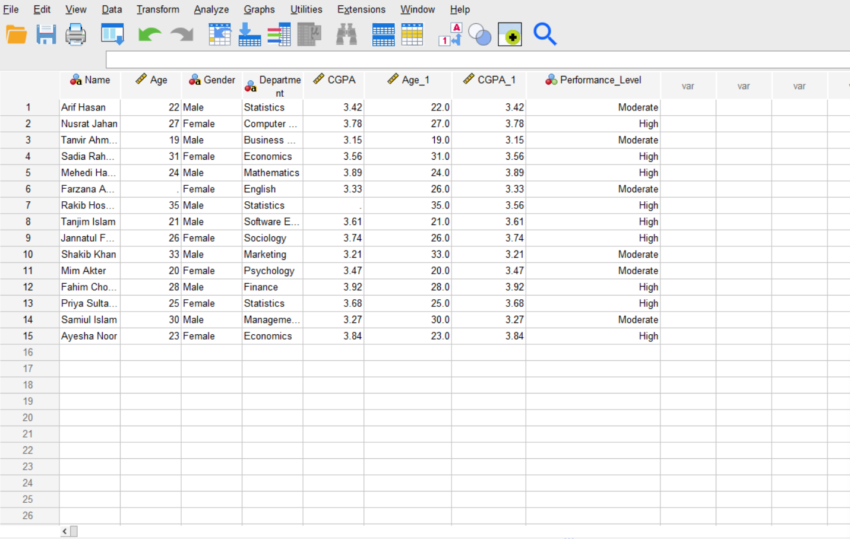
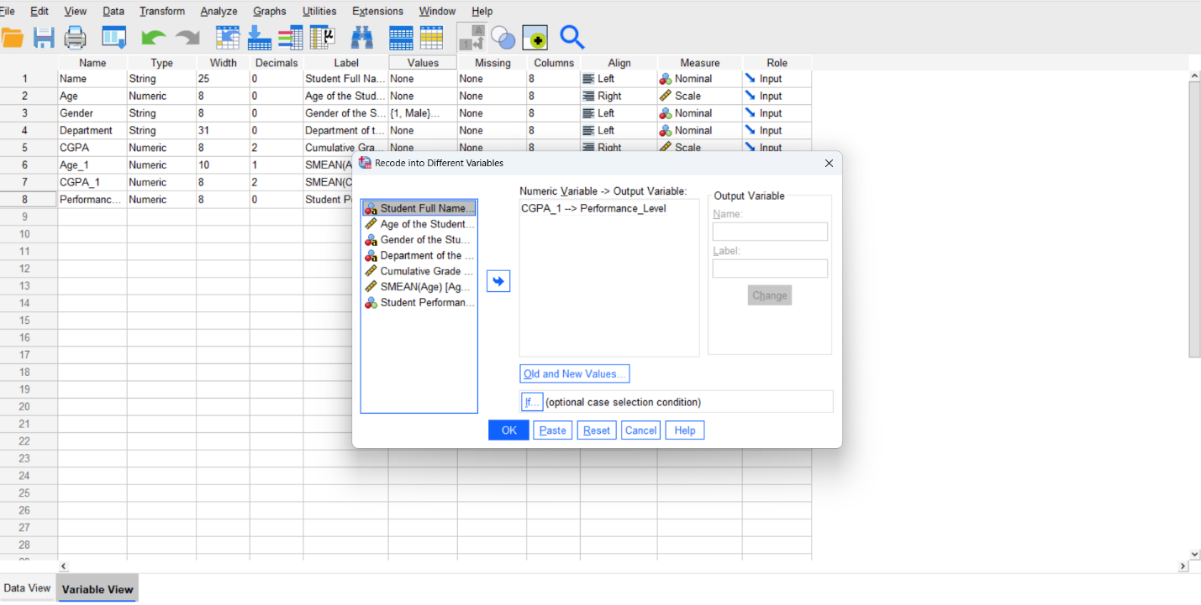
Interpretation: The dataset initially contained one missing value in both the Age and CGPA variables. To handle this problem properly, the missing values were replaced using the mean substitution method. After replacement, two new variables named Age_1 and CGPA_1 were created to store the cleaned values. This process improved the quality and completeness of the dataset, making it suitable for further statistical analysis.
Interpretation: The new variable **Performance Level** was created from the CGPA variable to categorize students based on their academic performance. Students with lower CGPA were classified as “Low,” moderate CGPA as “Moderate,” and higher CGPA as “High.” This transformation makes the data easier to interpret and helps compare student performance more effectively during analysis.
🔹 Task 3: Descriptive Statistics
Generate:
- Frequency table (Gender / Department)
- Mean, Median, Mode (Age / CGPA)
- Standard Deviation
🔹 Task 4: Interpretation
- What is the average age?
- Which gender appears most frequently?
- What does standard deviation indicate?

Gender of the Student
 |  | Frequency | Percent | Valid Percent | Cumulative Percent
Valid | Male | 8 | 53.3 | 53.3 | 53.3
 | Female | 7 | 46.7 | 46.7 | 100.0
 | Total | 15 | 100.0 | 100.0

Department of the Student
 |  | Frequency | Percent | Valid Percent | Cumulative Percent
Valid | Business Administration | 1 | 6.7 | 6.7 | 6.7
 | Computer Science & Engineering | 1 | 6.7 | 6.7 | 13.3
 | Economics | 2 | 13.3 | 13.3 | 26.7
 | English | 1 | 6.7 | 6.7 | 33.3
 | Finance | 1 | 6.7 | 6.7 | 40.0
 | Management Information Systems | 1 | 6.7 | 6.7 | 46.7
 | Marketing | 1 | 6.7 | 6.7 | 53.3
 | Mathematics | 1 | 6.7 | 6.7 | 60.0
 | Psychology | 1 | 6.7 | 6.7 | 66.7
 | Sociology | 1 | 6.7 | 6.7 | 73.3
 | Software Engineering | 1 | 6.7 | 6.7 | 80.0
 | Statistics | 3 | 20.0 | 20.0 | 100.0
 | Total | 15 | 100.0 | 100.0

Statistics
 |  | SMEAN(Age) | SMEAN(CGPA)
N | Valid | 15 | 15
 | Missing | 0 | 0
Mean |  | 26.000 | 3.5621
Median |  | 26.000 | 3.5621
Mode |  | 26.0 | 3.15ª
Std. Deviation |  | 4.7509 | .24926
a. Multiple modes exist. The smallest value is shown

Task 4: Interpretation
- The average age of the students is 26 years. This means most students in the dataset are around 26 years old on average.
- From the frequency table, the Male gender appears most frequently in the dataset.
- The standard deviation shows how much the data values vary from the mean.
  - The standard deviation of Age (4.7509) indicates that students’ ages are moderately spread around the average age.
  - The standard deviation of CGPA (0.24926) indicates that most CGPA values are close to the mean CGPA, meaning there is low variation in academic performance among students.

